Reactivating the Duo Mobile App
Faculty, staff, and students who changes phones (but keep the same phone number) or whose Duo App has stopped receiving push notifications, can reactivate their Duo App by following the instructions below.
- Go to https://mfagw.una.edu on your desktop or laptop (Not your phone).
- Login with your UNA ID and password.
- Click My Settings & Devices on the Choose an authentication method page.
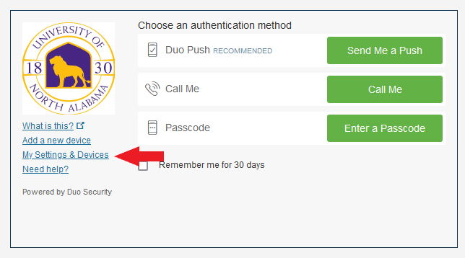
- When you are prompted to “Choose an authentication method,”
- Click on “Call Me”.
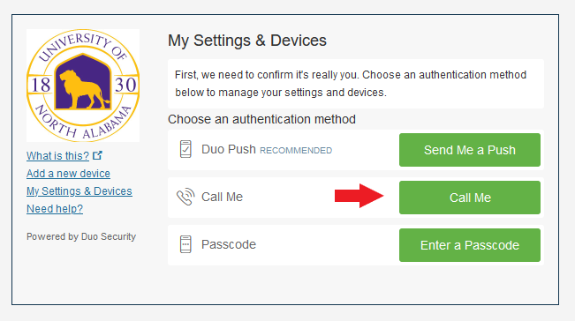
- Duo will now call your phone.
- When prompted, press 1 on your phone dial pad to log in.
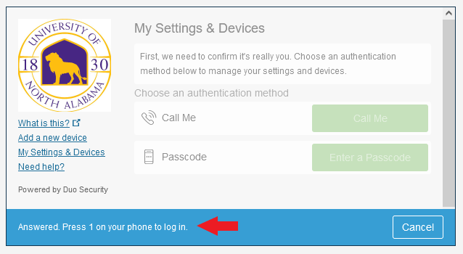
- You will now be taken back to the “My Settings & Devices” page.
- Click on “Device Options” next to the phone you have previously registered.
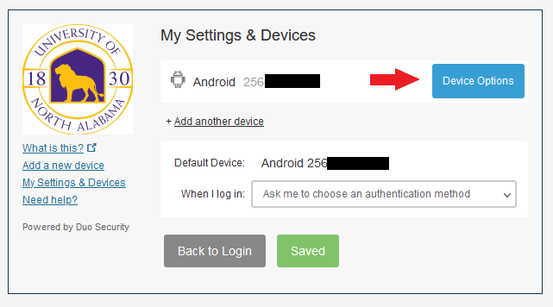
- On the next page, click on “Activate Duo Mobile”.
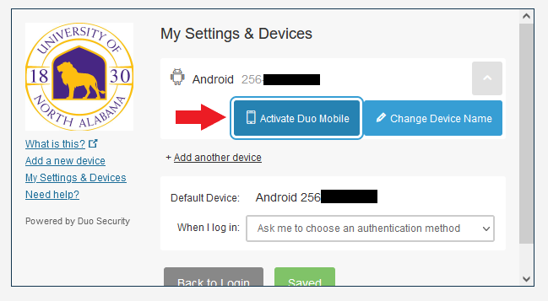
- On the “What type of phone” page, select the appropriate phone you own.
- Then click continue.
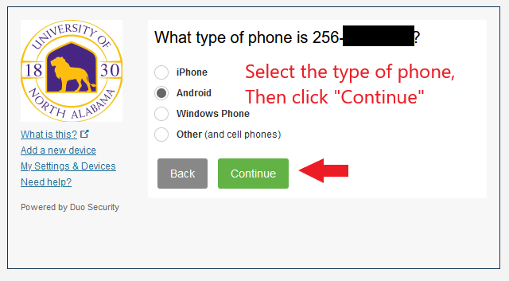
- On your phone, open the Duo App, and click the “+” symbol in the top right corner. This will bring up the camera inside the Duo app.
- Now hold your phone camera up to the QR code shown on the screen.
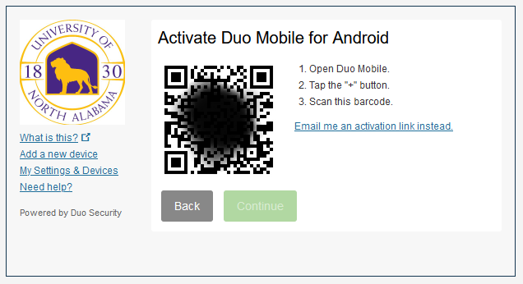
- If successful, a green check mark will appear over the QR code.
- Now click Continue.
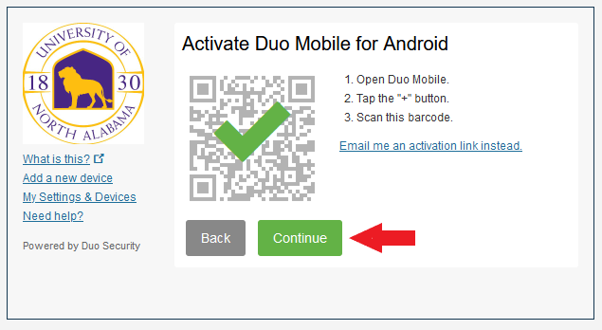
- Back on the “My Settings & Devices” page, click the pull-down menu next to “When I log in” and select “Automatically send this device a Duo Push”
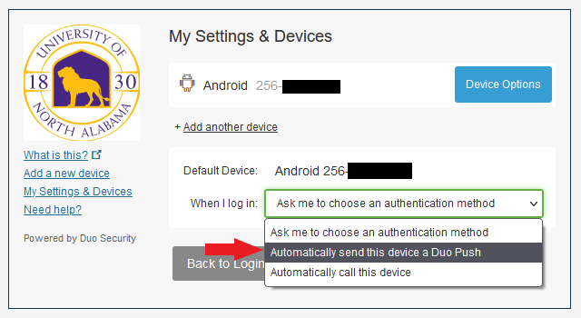
- Now click on the “Save” button to save your Duo settings.
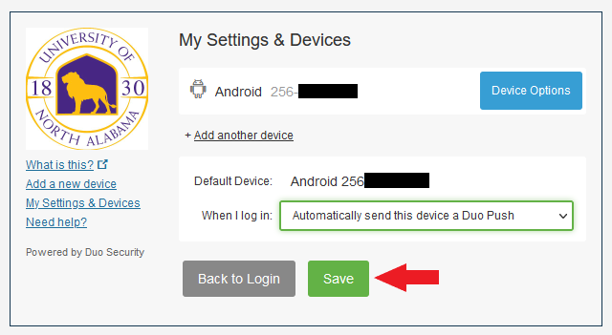
- Now click on “Back to Login” button.
- Duo will now send your device a push notification.
- Click on the notification on your phone, and then click “Approve”.
- If successful, you should see the screen below in your web browser.
