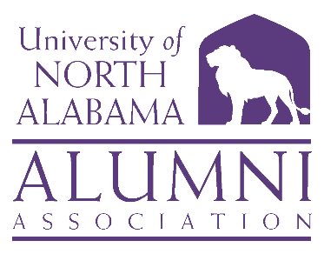
UNIVERSITY OF NORTH ALABAMA
ALUMNI ASSOCIATION BOARD
MARCH 21, 2024
1:30 P.M.
COBY HALL
Meeting ID: 284 970 654 881; Passcode: jqVjQu
AGENDA

- Call to Order and Invocation Ms. Savannah Liles ’11, Chair
- Roll Call and Quorum Ms. Gaye Choat, ’81, Secretary

- University and Advancement Update Ms. Barbie Terry, Associate Vice President
- Alumni Relations Update Mr. Bishop Alexander,’09, Director, Alumni Relations
- Committee Reports
  - Executive Committee Ms. Savannah Liles, ’11, Chair
  - Nominations Committee Mr. Will Hodges, ’10, Chair
  - Finance Committee Mr. Mike Byers, ’79, Chair
    - Budget (requires vote)
  - Marketing and Communication Ms. Rita Harris, ’85, Chair
  - Development Committee Mr. John Haeger, ’99, Chair
  - Campus Engagement Committee Ms. Anna Milwee, ’14, Co-Chair
Dr. Lisa Clayton, ’00, Co-Chair

- Old Business Ms. Savannah Liles, ’11, Chair
- New Business Ms. Savannah Liles, ’11, Chair
  - Constitution
  - Board Log-In
- Adjourn

