Center for Writing Excellence - Appointment Scheduling

1. Go to the Center for Writing Excellence homepage: http://www.una.edu/writingcenter/

2. Click “Schedule An Appointment”

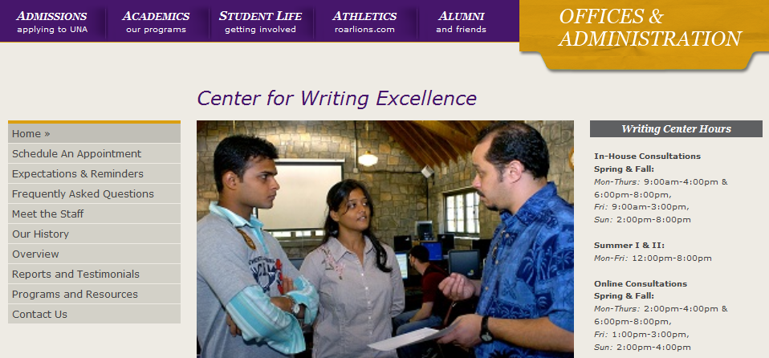

3. If you do not have an account you will need to register before scheduling appointments. To register, click the “click here to register” link, enter the required information, and click register.

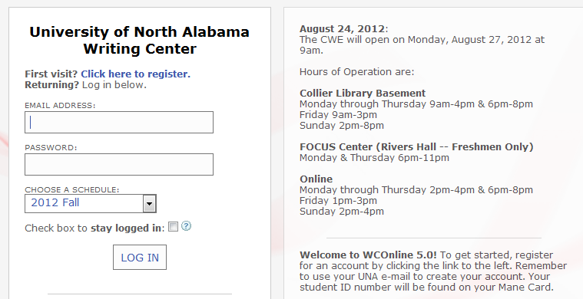

4. Login using your email address and password.

5. Once you are logged in you will see the scheduling page. A list of consultant’s names is on the left side of the screen. Note: Some consultants have “Online” next to their name. These appointments are reserved for distance learners. Do not schedule an online appointment if you are able to come in person. Online appointments are synchronous appointments (you will be online at the same time on the same website.)

Open appointments are in white.
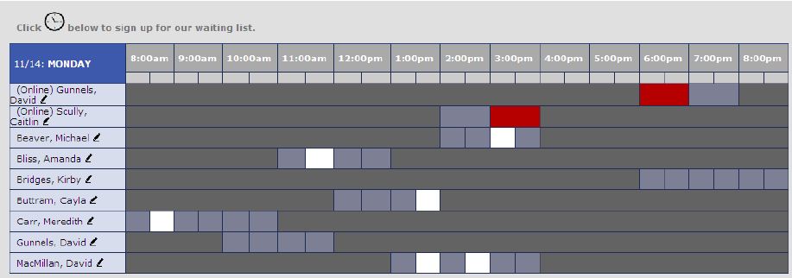

6. To schedule an appointment, locate the date you want and click on an open (white) appointment box.

7. Complete the appointment screen and click “Save Appointment” when finished

