Shared Governance
Document

University
of
North Alabama

December 1, 2013
Table of Contents

Overview 1
Constituent Roles 1
University Policy Change 3
Shared Governance Structure 5
Shared Governance Executive Committee 8
Strategic Committees:
Strategic Planning and Budget Study Committee 9
Academic and Student Affairs Committee 10
Institutional Effectiveness Committee 11
Faculty/Staff Welfare Committee 12
Infrastructure Development Committee 12

Task Committees:
Animal Care and Use Committee 13
Athletic Committee 14
Distance Learning Advisory Committee 15
Food Services Committee 15
Graphics Standards and Web Communications Committee 16
Human Research Participants Committee 17
International Programs/Offerings Committee 18
Multicultural Advisory Committee 19
Parking and Traffic Committee 19
Undergraduate Readmissions Committee 20
Research Committee 21
Safety and Emergency Preparedness Committee 21
Student Financial Services Committee 22
Technologies Advisory Committee 23

Campus Committees Outside the Shared Governance Structure:
Interdisciplinary Studies Degree Committee 24
Teacher Education Council 24
Commencement Committee 24
Homecoming Committee 24
Undergraduate Curriculum Committee 24
Graduate Council 24

Appendix A: Shared Governance Procedure for Policy Change Recommendations 25
Appendix B: Shared Governance Organizational Structure 28
Appendix C: Archives for Official Shared Governance Document 29

The University of North Alabama
Shared Governance Document
Revised December 1, 2013

A. Overview

This document is a statement of principles regarding shared governance, jointly developed and subscribed to by faculty, staff, and administration at the University of North Alabama. We are committed to a common vision of the mission of the institution. Further, we recognize that the success of the institution and the morale of the faculty, staff, students, and administration are dependent upon the legitimate involvement of these constituencies in the planning and decision-making processes of the University.

Shared Governance is a means of university management in which each chief group in the university community participates in decision making. This participation must be authentic and based on the principles that each group has the largest influence in matters that concern it most and that decisions made by shared governance constituent groups must have actual influence in university decision making. Shared governance includes mutual participation in the development of policy and decisions in the areas of strategic and budget planning, faculty and staff welfare, selection and retention of academic and administrative officers, campus planning and development, and organizational accountability.

These shared governance guidelines are intended to elaborate details in the way that faculty, staff, students, and administration address certain issues. These guidelines express a mutual desire to work together harmoniously and shall be interpreted to be consistent with all applicable laws, regulations, and the Bylaws of the Board of Trustees. They represent a commitment of the parties, not a legal contract.

B. Constituent Roles

1. The Faculty Role in Shared Governance

The faculty is the intellectual core of the University of North Alabama. It delivers instruction, carries out research, performs service for its professions and the community, and participates in the management of the University through shared governance. In the areas of intellectual development and instruction, the interest of the faculty is primary. The faculty will exercise its role in shared governance through and by service in the Faculty Senate, in the academic colleges and departments, and on university strategic and task committees. The faculty’s involvement in shared governance includes, but is not limited to, the areas of curriculum, subject matter and methods of instruction, university budgeting, research, faculty status, faculty employment and welfare, and those aspects of student life which relate to the educational process.

2. The Staff Role in Shared Governance

The purpose and role of the staff are to provide effective support structures for the University of North Alabama, provide educational support services, and complement educational programs. The role of the staff is to represent its areas of responsibility in shared governance. The staff will exercise its role in shared governance through and by service on the Staff Senate and on university strategic and task committees. The staff’s involvement in shared governance includes, but is not limited to, the areas of student affairs, financial services, academic support, research, advancement, physical resources, and staff/service employment and welfare.

3. The Student Role in Shared Governance

Students are free, individually and collectively, to express their views on issues of institutional policy and on matters of interest to the student body. The University seeks to ensure that students have appropriate input into the making of major policy, program, procedure, and budget decisions. The Student Government Association Senate (SGA)3 serves as the collective voice of the student body. The role and responsibilities of the Senate are described in detail in the SGA Senate Constitution and Code of Laws. The President of the University, the Vice President for Student Affairs, and the Director of Student Engagement maintain a close working relationship with the Student Government officers. Many other Recognized Student Organizations (RSOs) and groups provide valuable advice to the university administration on matters that are of particular interest to their membership or to students in general.

Students participate in the deliberations of official decision-making constituent groups at the University. Most important university committees that make or recommend institutional decisions include student members. However, students are not eligible to serve in vice chair and chair positions. The President of the SGA Senate meets regularly with the Board of Trustees to give student viewpoints on issues before the Board.

The university administration uses both formal and informal means in order to maintain an awareness of the needs and view of the students. The opinions of students are sought, heard, and considered in major decisions affecting virtually every facet of the University.

4. The Administration Role in Shared Governance

The responsibility of administrators in shared governance is to form and articulate a vision for the University, to provide strategic leadership, and to manage its resources, finances, external affairs, and operations.

Administrators participate in the shared governance process in a manner designed to foster the smooth, efficient, and effective management of the University, while involving faculty, staff, and students in decision making. The authority and duties of the President in this process are outlined in the Bylaws of the Board of Trustees and in the job description of the President. The responsibilities and duties of other administrators are described in their respective job descriptions.
C. University Policy Change

1. The Role of Shared Governance in University Policy Change

Any individual or group of the University (the Originator) may recommend changes to university policy. A written proposal is submitted to the Chair of the Shared Governance Executive Committee (SGEC). The role of Shared Governance is to ensure that UNA jointly involves faculty, staff, students, and administration in the development of university policies. Collaboration with all potential stakeholders is expected at every step in the development of change in university policy. The constituent groups are encouraged to consult one another.

2. Shared Governance Procedure for Policy Change Recommendations

The following procedure ensures that all proposals for policy change at UNA jointly involve the faculty, staff, students, and administration in the development of these policies. Because most faculty members are on nine month contracts, the procedures and time lines described in this section apply to the nine month academic calendar. Under normal circumstances, policy issues are not to be considered except during the nine month academic year. Appendix A contains a flow chart briefly outlining this policy change procedure.

- A written proposal is submitted to the SGEC. Upon receipt of a proposal, the SGEC first determines if the issue is editorial in nature and does not affect current policies. If editorial, the issue is addressed by the SGEC and sent directly to the President for approval. If the issue does affect current polices, the SGEC will determine if it affects only faculty or staff or students. If so, (Case 1) the SGEC sends the proposal to the respective Senate(s) within 15 calendar days of receipt of said proposal, not counting university holidays and breaks as published in the university calendar, to consider. If the SGEC determines that input from a Shared Governance committee or committees is warranted, the proposal will follow Case 2 (below) with the provision that it will only be sent to the affected constituency’s Senate(s). If the issue affects more than one constituency, (Case 2) the SGEC must determine which Shared Governance committee(s) or Senate(s) the proposal will be sent to and distribute the written proposal to that committee(s) and the appropriate Vice President within 15 calendar days of receipt of said proposal, not counting university holidays and breaks as published in the university calendar. If the SGEC does not move on the proposal within the specified time limit, the Originator has the authority to distribute said proposal to the appropriate Shared Governance committee.

- CASE 1: If the SGEC sends the proposal to the Faculty Senate or the Staff Senate or the Student Government Association Senate, that constituent group in consultation with the appropriate Vice President(s) considers the proposal and sends resulting recommendation(s) to the SGEC Chair for referral to the President. In the event the appropriate constituent group fails to act within 45 calendar days of receipt of said proposal, not counting university holidays and breaks as published in the university calendar, the SGEC sends the written proposal within 15 calendar days of the expiration of the review period to the President with its recommendation regarding implementation or returns the proposal to the Originator.

- CASE 2: Upon receipt of a proposal, a given Shared Governance committee must, within 45 calendar days of receipt of said proposal, not counting university holidays and breaks as published in the university calendar,
- accept the proposal as is and send it, with written comments/recommendations, to the SGEC Chair for referral to the Faculty Senate and/or the Staff Senate and/or the Student Government Association Senate (as directed by the SGEC) for action,
- accept the proposal with amendments. Both the original proposal and the amended version with written comments/recommendations are sent to the SGEC Chair for referral to the Faculty Senate and/or the Staff Senate and/or the Student Government Association Senate (as directed by the SGEC) for action, or
- reject the proposal and return it to the SGEC Chair for referral to the Originator with written comments/recommendations, or
- notify the SGEC, via the SGEC Chair, that a study requiring additional time is necessary before a recommendation can be made and indicate a timeframe for completion of the study and recommendation.

In the event the appropriate Shared Governance committee fails to do any of the above within 45 calendar days of receipt of said proposal, not counting university holidays and breaks as published in the university calendar, acquiescence is assumed and the SGEC distributes the written proposal within 15 calendar days of the expiration of the review period, not counting university holidays and breaks as published in the university calendar, to the Faculty Senate and/or the Staff Senate and/or the Student Government Association Senate.

The Faculty Senate, the Staff Senate, and the Student Government Association Senate must provide written comments/recommendations to the SGEC within 45 calendars days of receipt of said proposal. No response constitutes acquiescence to the proposal by the constituent group not responding. The Faculty Senate, the Staff Senate, or the Student Government Association Senate may ask the SGEC for an extension of up to 30 days if significant issues are addressed in the written proposal and additional time is deemed warranted. After the SGEC receives responses through the above processes and reconciles the differences, if there are any, the SGEC submits a report with recommendations to the President. If the differences are irreconcilable, the SGEC will send the recommendations to the original Shared Governance committee to which it was assigned and/or the Originator.

- Once a proposal has been accepted or accepted with modifications by the President, he/she may implement it as policy. The President, or his/her designee on behalf of the President, shall inform the campus community of the new policy/policy change via email.

3. The Role of the President in University Policy Change

The President of the University may seek an expedited review should he/she deem that essential. Under normal circumstances, policy issues are not to be considered except during the nine month academic year. The President may make exceptions and request an expedited review for those times when the health and wellbeing of the University, its faculty, staff, or students would be significantly and negatively impacted by lack of action.

D. Shared Governance Structure

- The Shared Governance Structure at UNA shall consist of three levels of committees:

- The Shared Governance Executive Committee

B. Strategic Committees
1. Strategic Planning and Budget Study Committee
2. Academic and Student Affairs Committee
3. Institutional Effectiveness Committee
4. Faculty/Staff Welfare Committee
5. Infrastructure Development Committee

C. Task Committees
1. Animal Care and Use Committee
2. Athletic Committee
3. Distance Learning Advisory Committee
4. Food Services Committee
5. Graphics Standards and Web Communications Committee
6. Human Research Participants Committee
7. International Programs/Offerings Committee
8. Multicultural Advisory Committee
9. Parking and Traffic Committee
10. Undergraduate Readmissions Committee
11. Research Committee
12. Safety and Emergency Preparedness Committee
13. Student Financial Services Committee
14. Technologies Advisory Committee

II. Reporting Structure:

A. The SGEC reports directly to the President.

B. The five Strategic Committees all report to the President through individual Vice Presidents as follows:

1. The Strategic Planning and Budget Study Committee reports through the Vice President for Academic Affairs (VPAA) and Provost.

2. The Academic and Student Affairs Committee reports through the VPAA and Provost.

3. The Institutional Effectiveness Committee reports through the VPAA and Provost.

4. The Faculty/Staff Welfare Committee reports through the Vice President for Business and Financial Affairs (VPBFA).

5. The Infrastructure Development Committee reports through the Vice President for Business and Financial Affairs (VPBFA).

C. The Task Committees report to the President through one of the University Vice Presidents as indicated in the reporting structure portion of the charge of the specific committee for each of these task committees and in the Shared Governance Organizational Structure in Appendix B.

III. All committees are advisory to the President. As provided by the Bylaws of the Board of Trustees, the President and the Board of Trustees retain final decision-making authority on all issues presented via the governance structure.

IV. Membership on all committees, other than membership by position and student members, is for staggered, three (3) year terms, with approximately one-third (1/3) of the members having terms expire each year. An individual may serve a maximum of two (2) consecutive three (3) year terms. After two consecutive terms on a committee, an individual must sit out for at least one (1) year before being eligible for re-appointment to that committee. Student members will serve one (1) year terms and may be reappointed. The SGEC will recommend appointments to the President for membership on all committees. Terms expire the day preceding the first day of the fall semester.

New terms begin on the first day of the fall semester. The President shall appoint all committees prior to the first day of each fall semester. Persons appointed to vacated positions will serve until the normal expiration of the term to which they were appointed. Students and non-voting members will not count towards quorums. If a voting member of a shared governance committee cannot attend a meeting, the member is responsible for selecting a proxy for that meeting. Non-voting and student members may also select proxies as needed. Proxies must represent the same constituency as the shared governance committee member represents and from which the member was appointed. A shared governance committee member may not use a proxy more than two times during an academic year.

Where this document calls for members recommended to the SGEC by the Faculty Senate, Staff Senate, or Student Government Association Senate, the Faculty Senate and Staff Senate and Student Government Association Senate should solicit interested candidates for committee membership from the entire faculty or entire staff or entire student body, and submit a slate of candidates at least as large as the number of open positions. The SGEC will review the nominations and submit its recommendations for membership appointments to the President. The SGEC will, to the degree possible, honor individual candidate’s committee preferences in its recommendations to the President. The constituent slates, however, are for service at large and as needed.

Nominations for membership on the SGEC require special consideration. Faculty nominated to the SGEC must be full-time tenured faculty with shared governance experience. Staff nominated to the SGEC must be full-time permanent staff with shared governance experience. Students nominated by the SGA Senate should have experience in high school or collegiate student government.

V. Membership on some committees (e.g., Strategic Planning and Budget Study Committee) may require a commitment on the part of the appointee to first attend educational sessions designed to prepare the appointee for service on the committee. For example, appointment to the Strategic Planning and Budget Study Committee may require the appointee to attend educational sessions to provide the appointee with the necessary background on budgeting and budget documents to participate in discussions of this committee. Similarly, service on the Faculty/ Staff Welfare Committee may require background sessions in insurance and compensation issues.

VI. The Shared Governance Structure at the University of North Alabama is envisioned as a separate but complementary structure on the Organizational Chart of the University as represented by the organizational structure model in Appendix B at the end of this document.

VII. At the beginning of each year, the SGEC and all strategic committees will select a chair and a vice-chair from among the eligible voting committee members. Normally, the previous year’s vice-chair will assume the chair position upon confirmation by the membership. The individual selected to serve as vice-chair should be willing and eligible to serve as chair during the following year. One of the responsibilities of the by-position members of the committees having administrative oversight of the areas within the committee’s charge is to coordinate with the chair of the committee for the smooth operation of the committee and the implementation of approved committee recommendations.

VIII. The SGEC recognizes that some committees may wish to establish subcommittees from time to time. Proposed subcommittees and the proposed charge and structure of their membership should be submitted to the SGEC as information. Membership of such subcommittees must be limited to members of the originating committee.

IX. The SGEC recognizes that some committees may wish to establish special work groups from time to time. Proposed work groups and the proposed charge and structure of their membership should be submitted to the SGEC for review and approval prior to their establishment by the committee. Membership of such work groups is not limited to members of the originating committee. The charge to such work groups must include an ending date for the work group’s charge.

X. Individual units of the University may establish committees intended to work on issues that do not significantly impact other units of the campus directly. No new standing or ad hoc university committees should be structured or appointed without prior review by the SGEC. This review should result in a written recommendation to the President regarding the impact of the proposed new committee on the shared governance structure of the University. Where possible, it should be the responsibility of the SGEC, in consultation with the President and the appropriate Vice President, to propose the structure, charge, membership, and reporting chain for all proposed committees. The President retains the authority to establish taskforces, working groups, or committees following consultation with the SGEC.

XI. All committee chairs, except where otherwise noted, will submit a year-end report to the Vice President specified in the committee’s reporting structure, and send an electronic copy to the Chair of the SGEC. The year-end report must address the committee’s charge and other matters of interest to the shared governance process, as indicated on the Annual Report template provided by the SGEC. This year-end report will ultimately go to the President and be posted to the Shared Governance Webpage.

XII. Individuals with administrative responsibility for a given area should not chair a strategic committee, but may chair a task committee. All members of committees who are serving by reference to a specific position are voting members unless otherwise specified.

XIII. Governance Committee Composition and Charge

Shared Governance Executive Committee

- Membership
- Four (4) full-time tenured faculty members recommended by the Faculty Senate with the concurrence of the President. The Chair is to be selected by the committee from among this group by mutual agreement of both the Committee and the President. The Chair should be a tenured senior faculty member respected by all campus constituencies.

- Two (2) Vice Presidents selected by the President

- One (1) College Dean recommended by the Council of Academic Deans with the concurrence of the President

- Two (2) staff members, at least one of whom must be below the rank of department chair/division director, recommended by the Staff Senate with the concurrence of the President

- One (1) representative of the Student Government Association Senate, recommended by the Student Government Association Senate President with the concurrence of the University President

- The presidents of the Faculty Senate and the Staff Senate in their particular year(s) of service in these leadership positions

B. Charge
- To serve as the “Committee on Committees” and annually make recommendations to the President regarding membership on all university committees covered by the governance structure

- To provide advice and counsel to shared governance committees in order to help these committees perform optimally

- To conduct ongoing review of the structure and composition of all university committees and to make recommendations to the President regarding changes in structure or committee composition

- To review all recommendations for the creation of new university committees, both standing and ad hoc, and to make recommendations to the President regarding their role and effect within the shared governance system

- To conduct ongoing review and evaluation of the effectiveness of the shared governance system and to propose to the President any adjustments or modifications suggested by this review

- To conduct an ongoing review of the effectiveness of communication of information within the shared governance system at all levels of the University and to make recommendations to the President regarding methods to improve communication where necessary

- To serve as the advisor to the President (and others) on assignment of issues to appropriate deliberative constituent groups, including assignment of issues to the SGEC itself

- To communicate its deliberations and findings to the President, and after discussion with the President, to the university community

- To receive all written proposed recommendations for policy change, distribute the written proposals to the appropriate Senate, Strategic, or Task Committee of Shared Governance within 15 calendar days of receipt of said proposal, not counting university holidays and breaks as published in the university calendar, and send written notification to the proposal originator of the proposal’s status

- To ensure the complete, accurate, and timely placement of changes in the Shared Governance Document and to reconcile these changes with the Assistant for Administration, President’s Office, and the Assistant to the Vice President for Academic Affairs and Provost, for the official Shared Government Document archive (Appendix C)

C. The SGEC reports directly to the President of the University.

XIV. Strategic Committees: Composition and Charge

- Strategic Planning and Budget Study Committee

A. Membership
1. Vice Presidents
2. One (1) member of the Council of Academic Deans, recommended to the SGEC by the Council of Academic Deans
3. Five (5) faculty members, recommended to the SGEC by the Faculty Senate
4. Athletic Director and three (3) staff members at large, recommended to the SGEC by the Staff Senate
5. One (1) representative from the Student Government Association Senate appointed by the Student Government Association Senate President
6. Vice President for Academic Affairs and Provost and the Director of Institutional Research, Planning, and Assessment are non-voting members of this committee

B. Charge
1. To participate in all aspects of strategic planning, including:
- Reviewing procedures for university strategic planning;
- Relating the strategic planning process to annual reports; and
- Reviewing progress and recommending updates to the University’s Strategic Plan annually
2. To conduct systematic reviews of expenditure needs and revenue needs including:
- Reviewing and prioritizing recommendations from all areas of the University concerning financial resource needs, based on the University’s Strategic Plan;
- Reviewing links between budget requests and departmental annual reports;
- Reviewing results reported by the Institutional Effectiveness Committee to support assessment, evaluation, and improvement;
- Reviewing prioritized recommendations from the Infrastructure Development Committee to monitor conformity with the University’s Strategic Plan; and
- Conducting systematic reviews of actual and planned expenditures.
3. To communicate its deliberations and findings to the President, and after discussion with the President, to the university community.

- This committee reports to the President through the Vice President for Academic Affairs and Provost.

2. Academic and Student Affairs Committee

A. Membership
1. Six (6) faculty members, one from each college and two at large, recommended to the SGEC by the Faculty Senate
2. Four (4) staff members, to include one or more from Student Affairs, recommended to the SGEC by the Staff Senate
3. Two (2) student members, recommended to the SGEC by the Student Government Association Senate President
4. One member of the Council of Academic Deans, recommended to the SGEC by the Council of Academic Deans
5. VPAA and Provost, VPSA, and other Council of Academic Deans members are non-voting members of this committee

B. Charge
1. To originate, review, recommend and report in the following areas:
a. Academic and/or Student Affairs policies and issues as received from the SGEC
b. Student recruitment, retention, and admissions
2. To communicate its deliberations and findings through the VPAA to the President, and after discussion with the President, to the university community
3. To handle any proposals the committee may make affecting university policy according to section C.2 “Shared Governance Procedure for Policy Change Recommendations”
4. To submit a final written report electronically by the first day of the fall semester to the Vice President for Academic Affairs and Provost with a copy sent to the Chair of the SGEC

C. This committee reports to the President through the Vice President for Academic Affairs and Provost.

3. Institutional Effectiveness Committee

- Membership
- One (1) Council of Academic Deans member, recommended to the SGEC by the Council of Academic Deans
- Two (2) staff members with institutional effectiveness (IE) reporting requirements, to be recommended to the SGEC by the Staff Senate
- Two (2) faculty members with IE reporting requirements, to be recommended to the SGEC by the Faculty Senate
- One (1) staff member from the Office of Institutional Research, Planning, and Assessment to be recommended to the SGEC by the Council of Academic Deans
- One (1) member of the Strategic Planning and Budget Study Committee (SPBSC), to be recommended to the SGEC by the SPBSC who will serve as liaison between the SPBSC and the IE Committee
- One (1) Southern Association of Colleges and Schools (SACS) liaison to be recommended to the SGEC by the Council of Academic Deans
- Director of Institutional Research, Planning, and Assessment

B. Charge
1. To recommend and develop procedures for planning and evaluating institutional effectiveness based on university goals, priorities, and the Strategic Plan
- To review and evaluate the use of assessment by institutional units and recommend improvement in the assessment process where necessary
- To review and evaluate the effectiveness of the institution’s responses to assessment and evaluation in the form of budgetary or programmatic modifications
- To review and evaluate the use of benchmarking by individual units for purposes of continual improvement of programs and/or services
- To communicate activities to the university community

- To handle any proposals the committee may make affecting university policy according to section C.2 “Shared Governance Procedure for Policy Change Recommendations”
7. To submit a final written report electronically by the first day of the fall semester to the Vice President for Academic Affairs and Provost with a copy sent to the Chair of the SGEC

C. This committee reports to the President through the Vice President for Academic Affairs and Provost and the Director of Institutional Research, Planning, and Assessment.

4. Faculty/Staff Welfare Committee

A. Membership
1. Four (4) faculty members, recommended to the SGEC by the Faculty Senate
2. Four (4) staff members, recommended to SGEC by the Staff Senate
3. One (1) member of the Council of Academic Deans, recommended to the SGEC by the Council of Academic Deans
4. Assistant Vice President of Human Resources and Affirmative Action, VPBFA, and Campus Safety Officer are non-voting members of this committee

B. Charge
1. To review and make recommendations on matters relating to faculty and staff welfare, including compensation, benefits, health and safety, and quality and equity of work issues
2. To communicate its deliberations and findings to the President, and after discussion with the President, to the university community
3. To handle any proposals the committee may make affecting university policy according to section C.2 “Shared Governance Procedure for Policy Change Recommendations”
4. To submit a final written report electronically by the first day of the fall semester to the Vice President for Business and Financial Affairs with a copy sent to the Chair of the SGEC

C. This committee reports to the President through the Vice President for Business and Financial Affairs.

5. Infrastructure Development Committee

A. Membership

1. Director of Facilities Administration and Planning, or designee
2. One (1) member of the Council of Academic Deans, recommended to the SGEC by the Council of Academic Deans
3. Three (3) faculty, recommended to the SGEC by the Faculty Senate
4. Two (2) staff, recommended to the SGEC by the Staff Senate

5. One (1) student, recommended to the SGEC by the Student Government Association Senate President
6. Campus Safety Officer
7. Disability Support Specialist
8. Vice President for Academic Affairs and Provost or designee, Vice President for Student Affairs or designee, Vice President for University Advancement, and Vice President for Business and Financial Affairs are non-voting members of this committee

B. Charge
1. To review and recommend updates to the campus master plan on a periodic basis
2. To evaluate recommendations concerning campus facilities that may need renovation or repairs as well as the need for new facilities or modified use of existing facilities
3. To prioritize the needs for renovation and repairs to campus facilities and infrastructure, including major technology components
4. To review all of these needs in light of the long-range goals of the University
5. To communicate its deliberations and findings to the President, and after discussion with the President, to the university community
6. To handle any proposals the committee may make affecting university policy according to section C.2 “Shared Governance Procedure for Policy Change Recommendations”
7. To submit a final written report electronically by the first day of the fall semester to the Vice President for Business and Financial Affairs with a copy sent to the Chair of the SGEC

C. This committee reports to the President through the Vice President for Business and Financial Affairs.

XV. Task Committees: Composition and Charge

1. Animal Care and Use Committee

A. Membership
1. One local DVM is a non-voting member of this committee
2. Four (4) faculty, recommended to the SGEC by the Faculty Senate, at least one of whom must be a practicing scientist experienced in research involving animals, and at least one whose primary concerns are in a non-scientific area
3. Two (2) staff members recommended to the SGEC by the Staff Senate
4. Director of Sponsored Programs or his/her designee is a non-voting member of this committee

B. Charge
1. To review compliance with and administer the Public Health Service Policy on the Care and Use of Laboratory Animals
2. To examine the Public Health Service Policy on the Care and Use of Laboratory Animals annually for policy changes
3. To propose changes in university practices relating to laboratory animals
4. To oversee and enforce the University Animal Welfare Policy
5. To handle any proposals the committee may make affecting university policy according to section C.2 “Shared Governance Procedure for Policy Change Recommendations”
6. To submit a final written report electronically by the first day of the fall semester to the Vice President for Academic Affairs and Provost with a copy sent to the Chair of the SGEC

C. This committee reports to the Vice President for Academic Affairs and Provost.

- Athletic Committee

A. Membership
1. Vice President for Business and Financial Affairs
2. Vice President for Student Affairs
3. Athletic Director
4. Director of Student Financial Services, or designee
5. Registrar
6. Senior Women’s Administrator
7. Six (6) faculty members, including the Faculty Athletics Representative, and five (5) recommended to the SGEC by the Faculty Senate
8. Three (3) student representatives, recommended to the SGEC by the Student Government Association Senate President

B. Charge
1. Ensure the proper role of athletics within the overall mission of the University
2. Ensure the integrity of the athletics program with regard to NCAA, Gulf South Conference, state and federal law compliance, gender equity, and support for the principles presented by the Knight Foundation’s Commission on Intercollegiate Athletics
3. Review and monitor (as necessary, assist in developing) all compliance procedures and recommend institutional procedural changes based upon changes in NCAA rules
4. Assign and document responsibilities for compliance tasks
5. Work to maintain the proper perspective of athletic competition within the university life of the student-athlete
6. Monitor the academic performance and progress made by student-athletes
7. Oversee all programs designed to ensure the academic success, personal development and personal welfare of student-athletes
8. To handle any proposals the committee may make affecting university policy according to section C.2 “Shared Governance Procedure for Policy Change Recommendations”
9. To submit a final written report electronically by the first day of the fall semester to the President with a copy sent to the Chair of the SGEC

C. This committee reports to the President.

- Distance Learning Advisory Committee

A. Membership
1. Four (4) faculty members from the College of Arts and Sciences, recommended to the SGEC by the Faculty Senate
2. Two (2) faculty members from the College of Business, recommended to the SGEC by the Faculty Senate
3. Two (2) faculty members from the College of Education and Human Sciences, recommended to the SGEC by the Faculty Senate
4. Two (2) faculty members from the College of Nursing, recommended to the SGEC by the Faculty Senate
5. One (1) library faculty member recommended to the SGEC by the Faculty Senate
6. One (1) representative from the Enrollment Management area recommended to the SGEC by the Staff Senate
7. Two (2) students, recommended to the SGEC by the SGA Senate
8. Assistant Director of Information Technology Services is a non-voting member of this committee
9. Chair of the Online Department of Nursing is a non-voting member of this committee
10. Disability Support Specialist is a non-voting, ex officio member of this committee
11. Vice President for Enrollment Management is a non-voting, ex officio member of this committee
12. One (1) faculty member from Educational Technology Services recommended to the SGEC by the ETS Director
13. Director of Professional, Interdisciplinary, and Continuing Education is a voting, ex officio member of this committee

B. Charge
1. To serve as a general advisory committee for the university's distance learning program
2. To aid the coordination of distance learning programs by gathering information on such programs across the campus and providing this information to program heads and administrators
3. To develop recommendations for the improvement of distance learning programs
4. To handle any proposals the committee may make affecting university policy according to section C.2 “Shared Governance Procedure for Policy Change Recommendations”
5. To submit a final written report electronically by the first day of the fall semester to the Vice President for Academic Affairs and Provost with a copy sent to the Chair of the SGEC

C. This Committee reports to the Vice President for Academic Affairs and Provost.

- Food Services Committee

- Membership
- Three (3) faculty members, recommended to the SGEC by the Faculty Senate
- Four (4) staff members – 1 from International Affairs, 1 from Residence Life, and 2 from the staff at large - recommended to the SGEC by the Staff Senate
- Three (3) members of the student body recommended to the SGEC by the SGA Senate President
- Student Government Association Senate President
- Vice President for Student Affairs, or designee is a non-voting member of this committee
- Vice President for Business and Financial Affairs, or designee
- General Manager of Food Services, is a non-voting, ex officio member of this committee
- Operational Manager of Food Services is a non-voting, ex officio member of this committee

Additional members may be added to this committee with approval of the SGEC.

- Charge
- To meet monthly each academic year to gain feedback and discuss issues, concerns, and new creative ideas for food services on campus
- To make recommendations to the Vice President for Student Affairs and the Vice President for Business and Financial Affairs for the purpose of improving food services
- To handle any proposals the committee may make affecting university policy according to section C.2 “Shared Governance Procedure for Policy Change Recommendations”
4. To submit a final written report electronically by the first day of the fall semester to the Vice President for Student Affairs with a copy sent to the Chair of the SGEC

- This committee reports to the Vice President for Student Affairs.

5. Graphics Standards and Web Communications Committee

- Membership
1. Director of University Communications and Marketing
2. Sports Information Director
3. One (1) member of the Council of Academic Deans, recommended to the SGEC by the Council of Academic Deans
4. One (1) member of the faculty, recommended to the SGEC by the Faculty Senate
5. One (1) faculty member from each of the Colleges of Arts and Sciences, Business, Education and Human Sciences, Nursing, and Collier Library
6. UNA Creative Director
7. Associate Director for Digital Communications
8. One (1) student representative, recommended to the SGEC by the Student Government Association Senate President
9. Coordinator of Academic Technology
10. Director of Admissions
11. Director of Alumni Relations
12. Vice President for University Advancement is a non-voting member of this committee

B. Charge
1. To serve as an advisory committee on the establishment and implementation of the university’s uniform graphics standards policies
2. To gather and review information on the use of university graphics on and off campus, and assess university graphics standards in light of the information obtained
3. To review the UNA Web Page regularly and to recommend changes to the page to ensure that it contains accurate, up-to-date information consistent with the graphic standards of the University
4. To propose changes for the improvement of university graphic and web materials and their uniform use
5. To handle any proposals the committee may make affecting university policy according to section C.2 “Shared Governance Procedure for Policy Change Recommendations”
6. To submit a final written report electronically by the first day of the fall semester to the Vice President for University Advancement with a copy sent to the Chair of the SGEC

C. This committee reports to the Vice President for University Advancement.

6. Human Research Participants Committee

A. Membership
1. Twelve (12) faculty members– recommended to the SGEC by the Faculty Senate:
Three (3) from Education and Human Sciences, to include at least one from Health, Physical Education, and Recreation,
Two (2) from Nursing,
One (1) from Business,
One (1) from Behavioral Sciences,
One (1) from Social Science,
Two (2) from Chemistry, Biology, or Physics,
An individual with primary concerns in non-scientific areas, and
An individual with primary concerns in scientific areas that traditionally do not use human research participants
2. Director of Sponsored Programs or his/her designee is a non-voting member of this committee
3. The committee must have one individual who is not affiliated with the University
4. The Vice Chair has the authority to act in the role of Co-Chair when required by federal grant regulations

B. Charge
1. To review compliance with and administer the University of North Alabama policy on the Use of Human Research Participants
2. To examine the University of North Alabama policy on the Use of Human Research Participants annually and assess university practices in light of the information obtained
3. To propose changes in university practices relating to the use of human research participants
4. To handle any proposals the committee may make affecting university policy according to section C.2 “Shared Governance Procedure for Policy Change Recommendations”
5. To submit a final written report electronically by the first day of the fall semester to the Vice President for Academic Affairs and Provost with a copy sent to the Chair of the SGEC

C. This committee reports to the Vice President for Academic Affairs and Provost.

7. International Programs/Offerings Committee

A. Membership
1. Six (6) faculty members, with at least one representative from each college, recommended to the SGEC by the Faculty Senate
2. Senior Vice Provost for International Affairs
3. One (1) representative from the Enrollment Management area, recommended to the SGEC by the Staff Senate
4. One (1) international student representative, recommended to the SGEC by the Student Government Association Senate President
5. Vice President for University Advancement
6. One (1) faculty member who has successfully led a UNA credit-bearing study abroad program within the previous three years
7. One (1) student member who has successfully completed a UNA sanctioned study abroad program within the previous three years

B. Charge
1. To serve as an advisory committee to international programs/offerings on campus
2. To assist the Office of International Affairs with information related to international programs/offerings on campus
3. To provide a mechanism for coordinating all programs/offerings within various colleges as well as other areas on campus
4. To serve as a mechanism for international offerings/program development
5. To handle any proposals the committee may make affecting university policy according to section C.2 “Shared Governance Procedure for Policy Change Recommendations”
6. To submit a final written report electronically by the first day of the fall semester to the Vice President for Academic Affairs and Provost with a copy sent to the Chair of the SGEC

C. The committee reports to the Vice President for Academic Affairs and Provost.

8. Multicultural Advisory Committee

A. Membership
1. Eight (8) faculty members, 2 from each of the colleges chosen to reflect the diverse groups and cultures at the University of North Alabama and recommended to the SGEC by the Faculty Senate
2. Two (2) students, recommended to the SGEC by the Student Government Association Senate President
3. Two (2) members of the staff, recommended to the SGEC by the Staff Senate
4. One (1) member of the staff from International Affairs
5. One (1) member of the staff from Student Engagement
6. Director of the Office of Diversity and Institutional Equity is a non-voting member of this committee

B. Charge
1. To serve as an advisory committee for the examination of issues of campus diversity and multiculturalism
2. To gather and review information on university diversity and multiculturalism and assess university performance in these areas in light of the information obtained
3. To propose changes in campus policies, procedures, and programs related to diversity and multiculturalism
4. To work closely with the Office of Diversity and Institutional Equity regarding diversity issues
5. To handle any proposals the committee may make affecting university policy according to section C.2 “Shared Governance Procedure for Policy Change Recommendations”
6. To submit a final written report electronically by the first day of the fall semester to the Vice President for Academic Affairs and Provost with a copy sent to the Chair of the SGEC

C. This committee reports to the Vice President for Academic Affairs and Provost.

9. Parking and Traffic Committee

A. Membership
1. Four (4) members of the faculty, recommended to the SGEC by the Faculty Senate
2. Two (2) staff members, recommended to the SGEC by the Staff Senate
3. Three (3) students, recommended to the SGEC by the SGA Senate
4. Director of University Police

B. Charge
1. To serve as an advisory committee in areas including parking planning, allocation, and enforcement
2. To provide a system of appeals for those receiving traffic citations
3. To serve as a hearing tribunal by hearing appeals and rendering decisions as to the appropriateness of citations

4. To hold hearings as regularly as possible to ensure the expeditious processing of appeals
5. To review and recommend changes to the parking and traffic policies, reserved parking space policies, and the parking fee and fine structure at the University as appropriate
6. To forward to the Vice President for Student Affairs for action any decision made by the Parking and Traffic Committee
7. To gather and review information on university parking planning, allocation, and enforcement and related areas and assess university performance in these areas in light of the information obtained
8. To propose changes in university parking planning, allocation, and enforcement and related areas
9. To handle any proposals the committee may make affecting university policy according to section C.2 “Shared Governance Procedure for Policy Change Recommendations”
10. To submit a final written report electronically by the first day of the fall semester to the Vice President for Student Affairs with a copy sent to the Chair of the SGEC

C. This committee reports to the Vice President for Student Affairs.

10. Undergraduate Readmissions Committee

A. Membership
1. Two (2) faculty members from the College of Arts and Sciences, recommended to the SGEC by the Faculty Senate
2. Two (2) faculty members from the College of Business, recommended to the SGEC by the Faculty Senate
3. Two (2) faculty members from the College of Education and Human Sciences, recommended to the SGEC by the Faculty Senate
4. Two (2) faculty members from the College of Nursing, recommended to the SGEC by the Faculty Senate
5. Two (2) students, recommended to the SGEC by the SGA Senate
6. Vice President for Enrollment Management is a non-voting member of this committee
7. International Affairs Admissions Coordinator is a non-voting, ex officio member of this committee

B. Charge
1. To serve as an advisory committee on undergraduate readmissions and allied issues
2. To serve as a board of appeal on undergraduate readmissions
3. To gather information on undergraduate readmissions and allied issues and assess university performance in these areas in light of the information obtained
4. To propose changes in university policy and procedures on under-graduate readmissions and allied issues
5. To handle any proposals the committee may make affecting university policy according to section C.2 “Shared Governance Procedure for Policy Change Recommendations”

6. To submit a final written report electronically by the first day of the fall semester to the Vice President for Academic Affairs and Provost with a copy sent to the Chair of the SGEC

- This committee reports to the Vice President for Enrollment Management.

11. Research Committee

A. Membership
1. Five (5) faculty members, recommended to the SGEC by the Faculty Senate
2. One (1) college dean, recommended by the Council of Academic Deans
3. Director of Sponsored Programs or his/her designee is a non-voting member of this committee

B. Charge
1. To serve as an advisory committee on the university’s research function and related issues
2. To serve as a screening board, recommending action for university released time and non-released time research grants (not including those grants given through individual college research committees)
3. To gather information on the University’s research efforts and related issues, and assess university performance in these areas in light of the information obtained
4 To propose changes in university policies, procedures, and practices on research and related issues
5. To handle any proposals the committee may make affecting university policy according to section C.2 “Shared Governance Procedure for Policy Change Recommendations”
6. To submit a final written report electronically by the first day of the fall semester to the Vice President for Academic Affairs and Provost with a copy sent to the Chair of the SGEC

C. This committee reports to the Vice President for Academic Affairs and Provost.

12. Safety and Emergency Preparedness Committee

A. Membership
1. Director of University Police
2. One (1) member of the Council of Academic Deans, recommended to the SGEC by the Council of Academic Deans
3. Director of Information Technology Services
4. Director of Facilities Administration and Planning
5. Assistant Vice President of Business Services
6. Director of University Health Services
7. Director of Residence Life
8. Network Services Manager
9. Four (4) faculty members, including one from Art, one from Biology, and one from Chemistry and Industrial Hygiene, recommended to the SGEC by the Faculty Senate
10. Vice President for Student Affairs
11. A member of the Lauderdale County Emergency Management Agency is a non-voting member of this committee

B. Charge
1. To serve as an advisory committee on the university's emergency/ disaster preparedness and other safety and health matters
2. To continually review the university's emergency/disaster preparedness plans and other policies and procedures on allied safety and health matters
3. To develop and edit the University Safety and Health Manual
4. To gather information about the university's emergency/disaster preparedness plans and on other allied safety and health matters, and assess university performance in these areas in light of the information obtained
5. To propose changes in the university's emergency/disaster preparedness plans and in other policies and procedures on allied safety and health matters
6. To handle any proposals the committee may make affecting university policy according to section C.2 “Shared Governance Procedure for Policy Change Recommendations”
7. To submit a final written report electronically by the first day of the fall semester to the Vice President for Academic Affairs and Provost with a copy sent to the Chair of the SGEC

C. This committee reports to the Vice President for Academic Affairs and Provost.

13. Student Financial Services Committee

A. Membership
1. Five (5) faculty members, recommended to the SGEC by the Faculty Senate
2. One (1) staff member, recommended to the SGEC by the Staff Senate
3. Controller
4. Vice President for Enrollment Management is a non-voting member of this committee
5. Director of Student Financial Services is a non-voting member of this committee
6. Director of Athletics
7. Vice President for University Advancement

B. Charge
1. To serve as an advisory committee in the area of student financial services
2. To serve as a board of appeal on financial aid awards
3. To gather information on student financial services and allied fields, and assess these services in light of the information obtained
4. To propose changes in student financial aid policies and procedures consistent with federal, state, and NCAA regulations and donor agreements

5. To handle any proposals the committee may make affecting university policy according to section C.2 “Shared Governance Procedure for Policy Change Recommendations”
6. To submit a final written report electronically by the first day of the fall semester to the Vice President for Academic Affairs and Provost with a copy sent to the Chair of the SGEC

C. This committee reports to the Vice President for Enrollment Management.

14. Technologies Advisory Committee

A. Membership
1. Five (5) faculty members, recommended to the SGEC by the Faculty Senate: two from the College of Arts and Sciences, one each from the College of Business, the College of Education and Human Sciences, and the College of Nursing
2. One (1) library faculty member, recommended to the SGEC by the Faculty Senate
3. One (1) staff member from Enrollment Management, recommended to the SGEC by the Staff Senate
4. One (1) student, recommended to the SGEC by the SGA Senate
5. Associate Director for Digital Communications is a voting, ex officio member of this committee
6. Vice President for Enrollment Management (or designee) is a non-voting member of this committee
7. Controller
8. Director of Information Technology Services is a non-voting member of this committee
9. A faculty or staff representative from Educational Technologies Services is a non-voting member of this committee
10. Chair of the Computer Science and Information Systems Department is a non-voting member of this committee

B. Charge
1. To serve as an advisory committee in the areas related to technology development, acquisition, and management including: networks, cable television, telephone system, computer laboratories and systems
2. To gather information on areas related to technology development, acquisition, and management, and to assess university needs and performance in light of the information obtained
3. To propose changes in areas related to technology development, acquisition, and management including policies, procedures, and products use
4. To handle any proposals the committee may make affecting university policy according to section C.2 “Shared Governance Procedure for Policy Change Recommendations”
5. To submit a final written report electronically by the first day of the fall semester to the Vice President for Academic Affairs and Provost with a copy sent to the Chair of the SGEC

- This committee reports to the Vice President for Academic Affairs and Provost.

XVI. Campus Committees Outside the Shared Governance Structure

1. Interdisciplinary Studies Degree Committee
This committee reports to the Vice President for Enrollment Management.

2. Teacher Education Council
This committee reports to the Dean of the College of Education and Human Sciences.

3. Commencement Committee
A. This committee reports to the Vice President for Academic Affairs and Provost.
B. All recommendations which concern substantive changes and procedures will be referred through the Vice President for Academic Affairs and Provost to the appropriate Shared Governance committee.

4. Homecoming Committee
A. This committee reports to the Vice President for University Advancement.
B. All recommendations which concern substantive changes and procedures will be referred through the Vice President for University Advancement to the appropriate Shared Governance committee.

5. Undergraduate Curriculum Committee
This committee reports to the President through the Vice President for Academic Affairs and Provost.

6. Graduate Council
This Council reports to the President through the Vice President for Academic Affairs and Provost.
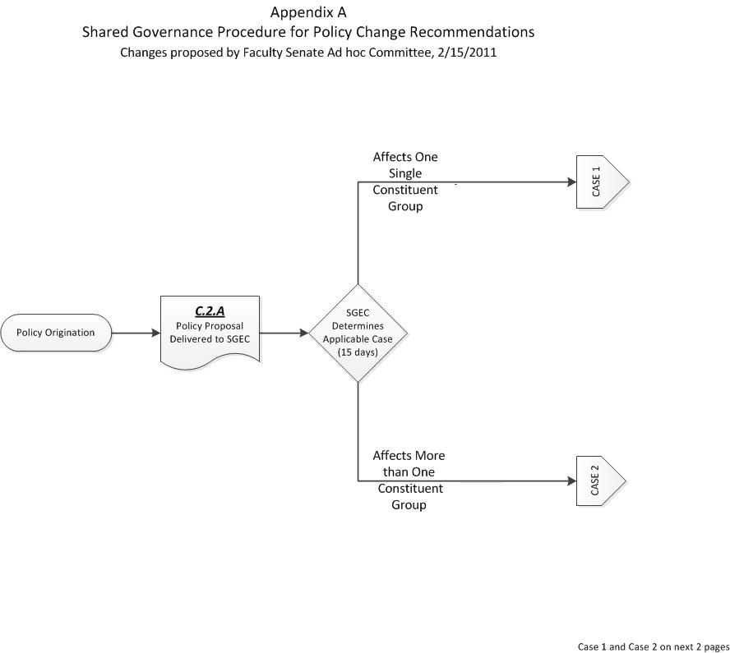
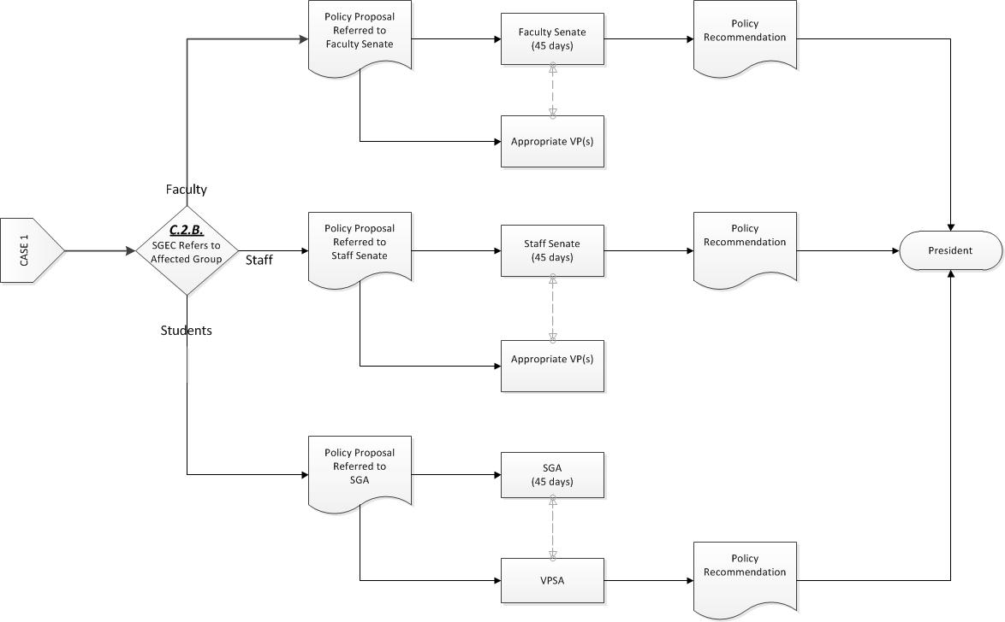

SGEC
Appendix A, Page 2
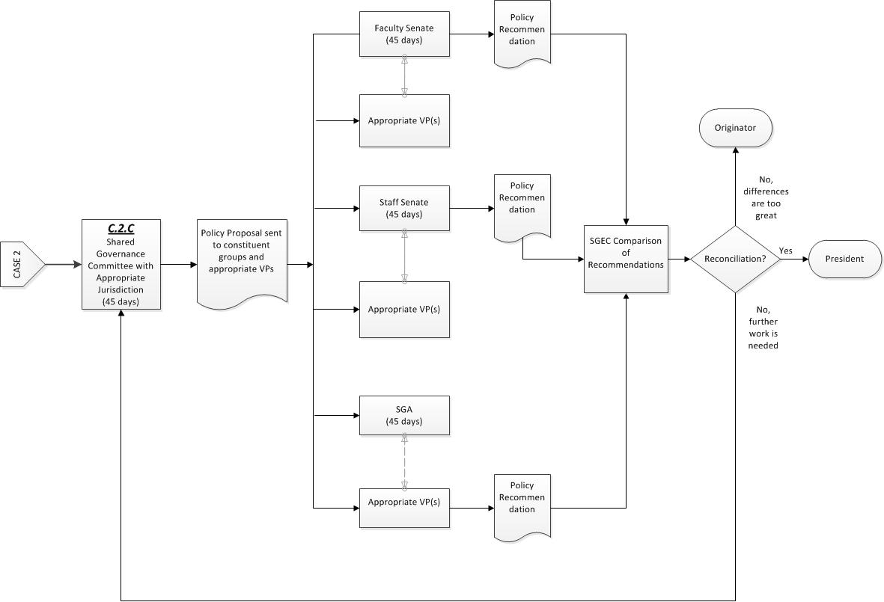
Appendix A, page 3
See separate document for Appendix B (Power Point document)
APPENDIX C

Archives for Official Shared Governance Documents

The Shared Governance Document is a statement of principles regarding shared governance, jointly developed and subscribed to by faculty, staff, and administration at the University of North Alabama. As such, the complete, accurate, and timely placement of changes in the Shared Governance Document is paramount to the cooperative management of the University. Archiving an official copy of the Shared Governance Document is necessary to ensure the accuracy and timeliness of the guidelines to be followed by the constituent groups in the shared governance process of the University.

The Official Shared Governance Document will be kept in the office of the Assistant for Administration, President’s Office, the office of the Assistant to the Vice President for Academic Affairs and Provost, and the office of the SGEC. Each office will maintain a hard copy and an electronic copy of the Official Shared Governance Document. At the beginning of his/her term, the Chair of the SGEC will obtain both a hard copy and electronic copy of the official document, disseminate this to the members of the SGEC and assure the Shared Governance web site is updated. At the end of his/her term, the Chair of the SGEC will reconcile with the Assistant for Administration, President’s Office, and the Assistant to the Vice President for Academic Affairs and Provost, any changes that have been approved during the course of the year and will then pass along the updated hard copy and electronic copy to the new Chair and to the Assistant for Administration, President’s Office and the Assistant to the Vice President for Academic Affairs and Provost. The SGEC office, the Assistant for Administration, President’s Office, and the Assistant to the Vice President for Academic Affairs and Provost will also house an official copy of shared governance records including SGEC meeting agenda and minutes.

The conceptual ideas in this overview are based primarily on material from the following resources: AAUP Statement on Governance: http://www.aaup.org/statements/Redbook/Govern.htm AGB Statement on Governance: http://www.agb.org/_content/trusteeship/v4n5/PRESIDEN.HTM U. of Arizona "Memorandum of Understanding on Shared Governance": http://w3fp.arizona.edu/senate/shared governance.html University System of Maryland Document on "Shared Governance: Definition, Rationale, Principles, and Recommendations: http://www.inform.umd.edu/UMS+State/UMD-Projects/cusf/WEB/reports_to_USM/shared_governance.html Illinois State Univ. Policy on Shared Governance: http://www.policy.ilstu.edu/govern_doc/govn_statu.
Definition of staff as outlined in the University of North Alabama Staff Senate Bylaws includes all regular, full- or part-time, exempt and non-exempt employees of the University other than faculty and with at least six months of service with the University – with the exception of the President, Vice Presidents, and deans. 3Note: In Section C below, the SGA Senate is included in the term “Senates” along with the Faculty Senate and the Staff Senate.

